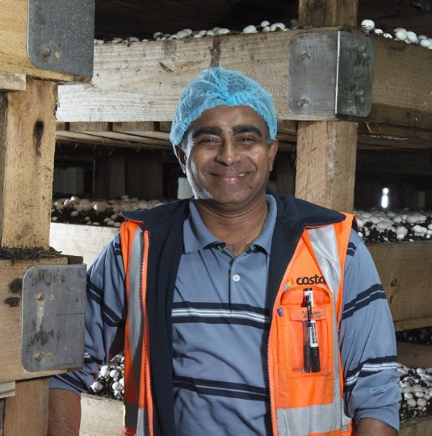

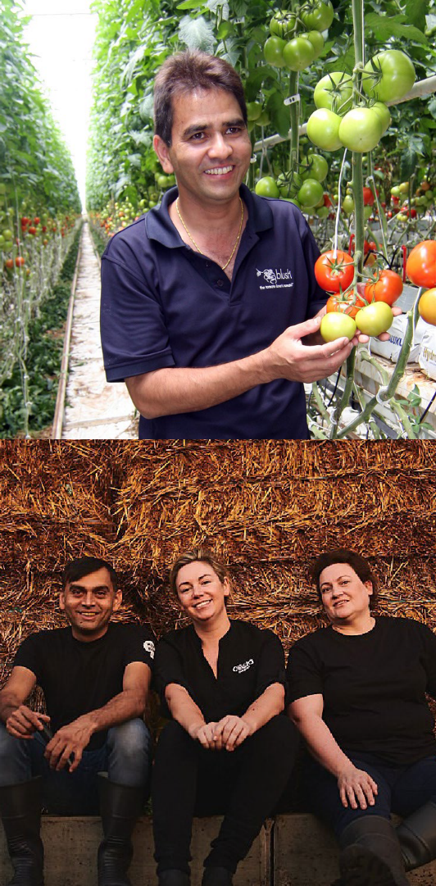
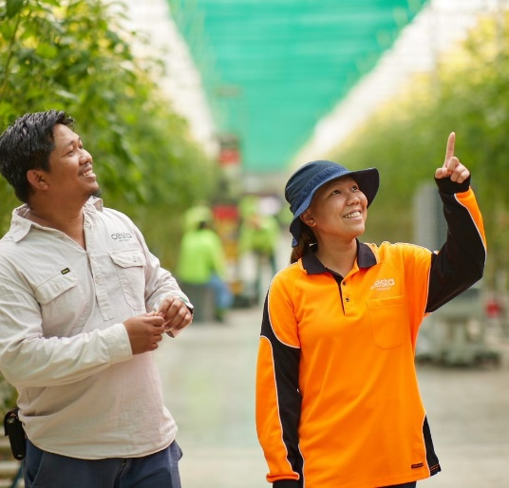
Work with us!

Senior Horticulture Grower

Category: Location:

Vertical Farming Mushroom Mernda, Victoria

Job type: Fulltime

Closing Date: 4 January 2026

About us:

The Costa Mushroom team is passionate about growing the best quality mushrooms. Our carefully managed crops are tendered by our highly skilled team of committed growers. With full ownership of our farm, we retain control of the entire growing and distribution process and can confidently deliver the freshest, highest standard of mushrooms.

About the role:
We are currently seeking a Senior Horticulture Grower to join our dynamic team based in Mernda, Victoria. In this position you will manage the growing function to achieve maximum product yield and quality by the daily environmental control of the crop through cultural practices, hygiene procedures, and monitoring of pests and diseases.

Key responsibilities include:
- Monitoring key growing parameters in the growing rooms and adjust as required.
- Monitoring & managing watering requirements for crops.
- Regularly check and maintain growing rooms equipment and facilities.
- To assist harvesting in the provision of daily and weekly crop estimates.
- The ability to advise harvesting personnel on selective picking for each growing room.
- Regular communication with Phase II personnel on the casing requirements and growing issues.
- Ability to communicate and report on growing/crop/disease information accurately in meetings or farm reports as required.
- Use of chemicals in accordance with recommended guidelines and safety procedures.

About you:
- 5+ years of previous experience in a similar role or industry is essential.
- Holder of Masters in Agricultural Management in Crop Protection (specifically mushrooms)
- Agriculture Honours Degree advantageous
- Chemical certification is required.
- Able to demonstrate time management and organisational skills.
- Working knowledge of the chemical handing rules and regulations.
- Working knowledge of HACCP and SQF.
- Good problem-solving skills.
- Good communication both verbally and written.
- Intermediate computer skills.

For further information about this role, please contact:
Melanie Harbord
HR Business Partner Victoria – Vertical Farming
M: 0484 409 326
E: melanie.harbord@costagroup.com.au

